May 16, 2013

TO: All Historic Saratoga-Washington on the Hudson Partnership Members

FROM: Chairman Tom Richardson

REGARDING: June 3rd, 2013 Meeting

Hello All,

Our next meeting will be 10 AM Monday, June 3rd, 2013 at the Town of Saratoga Town Hall in Schuylerville. Please call Supervisor Tom Wood at 695-3644 ext 314 if you are in need of directions. Enclosed in this packet are the minutes from the April 29th meeting and a tentative agenda for the upcoming meeting. Please observe that David King from the EPA will be attending this meeting to present information on the Hudson River Dredging Project and answer any questions you may have. If you have anything you would like to add to agenda, or any corrections and comments on the minutes, please contact Devin Lander at 455-4805 or at landerd@assembly.state.ny.us This information is also available online at our new website www.hudsonhoosicpartnership.org.

As you know, the Partnership has expanded recently and therefore the number of voting members needed to reach a quorum has risen. As a result, we need voting members to attend the monthly meetings. However, if you cannot attend, please send a proxy to vote in your place.

Sincerely,

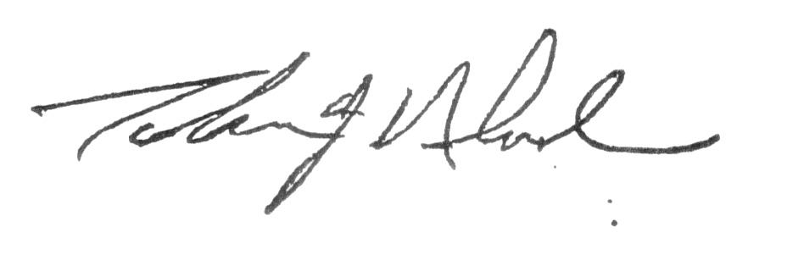

________________________________Tom Richardson, Chair

