January 16, 2014

TO: All Historic Saratoga-Washington on the Hudson Partnership Members

FROM: Chairman Tom Richardson

REGARDING: Next Meeting January 27th

Hello All,

Our next meeting will be held at 10 AM Monday, January 27th, 2014 at the Town of Saratoga Town Hall in Schuylerville. Please call Supervisor Tom Wood at 695-3644 ext 314 if you are in need of directions. Enclosed in this packet are the minutes from the December 2nd meeting and a tentative agenda for the upcoming meeting. If you have anything you would like to add to agenda, or any corrections and comments, please contact Devin Lander at 455-4805 or at landerd@assembly.state.ny.us This information is also available online at our new website www.hudsonhoosicpartnership.org.

As you know, the Partnership has expanded recently and therefore the number of voting members needed to reach a quorum has risen. As a result, we need voting members to attend the monthly meetings. However, if you cannot attend, please send a proxy to vote in your place.

Sincerely,

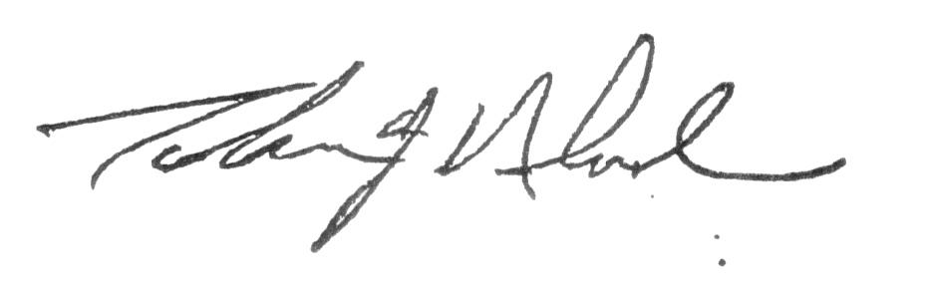

________________________________Tom Richardson, Chair

